Hotel booking analysis
Initial tasks
TASK 1 .Data Cleaning: Handling missing values, correcting data types, and removing duplicates.
Ans Approach:
Missing Values Handling:
The dataset was first checked for missing values using df.isnull().sum().sort_values(ascending=False). The output showed missing values in company, agent, country, and children columns.

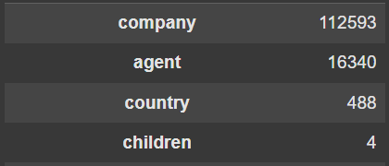
- children: 4 missing values were filled with 0 using df['children'].fillna(0, inplace=True), assuming no children were associated with those bookings.
- country: 488 missing values were replaced with 'Unknown' using df['country'].fillna('Unknown', inplace=True) so that records were retained without dropping rows.
- agent: 16,340 missing values were filled with 0 using df['agent'].fillna(0, inplace=True), representing bookings where agent information was not available.
- company: 112,593 missing values were filled with 0 using df['company'].fillna(0, inplace=True), indicating bookings without company details or direct bookings.
Duplicates:
Duplicate records were removed using df.drop_duplicates(inplace=True) to avoid redundancy and ensure that the analysis was performed on unique booking entries only. After removing duplicates, the number of records reduced from 119,390 to 87,396, improving the overall data quality.
Data Type Conversions:
To prepare the dataset for further analysis, necessary data type conversions were performed:
- reservation_status_date was converted from object type to datetime format using pd.to_datetime() to support time-based analysis.
- agent and company columns were converted into integer type after filling missing values with 0, ensuring consistency in numeric processing.
Final Outcome:
After performing missing value treatment, duplicate removal, and data type corrections, the dataset became clean and analysis-ready. All missing values were handled successfully, duplicate entries were removed, and important fields were converted into appropriate formats for further descriptive, visual, and time-series analysis.
Task 2 Descriptive Statistics: Generating summary statistics for numerical and categorical variables.
Ans Approach:
Descriptive Statistics: In this step, descriptive statistics were generated separately for both numerical and categorical variables to understand the overall structure of the dataset.
For numerical variables, df.describe() was used to calculate summary measures such as count, mean, standard deviation, minimum, maximum, and quartiles. This helped in understanding the distribution, central tendency, and spread of the numerical columns.
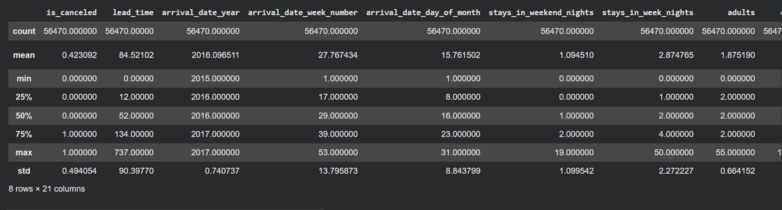
For categorical variables, df.describe(include=object) was used to summarize features such as count, number of unique values, most frequent category, and frequency of the top category. This helped in understanding the pattern and distribution of non-numeric columns in the dataset.
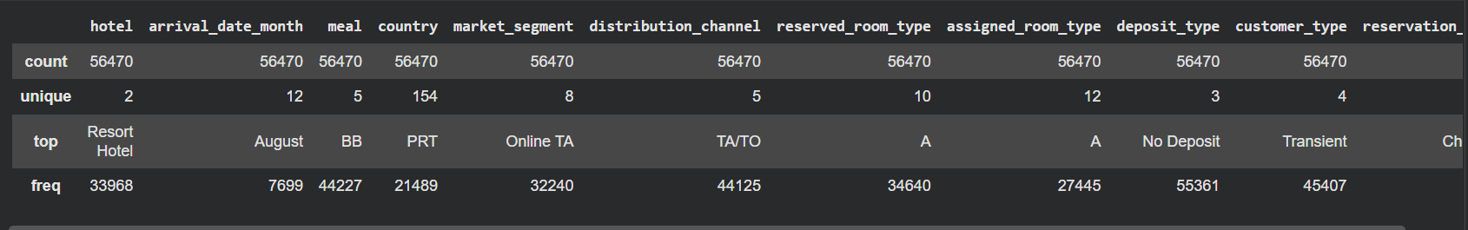

Task 3 Data Visualization: Creating visualizations to understand the distribution of variables and relationships between them.
Ans Approach:
Ans Approach:- 3.1 :- Booking Cancellation Distribution :-
This chart shows how many bookings were canceled versus not canceled. It helps us quickly understand the overall cancellation trend and compare the number of canceled bookings with completed bookings.
ax = sns.countplot(data=df, x='is_canceled')
plt.title('Booking Cancellation Distribution')
plt.xlabel('Is Canceled (0 = No, 1 = Yes)')
plt.ylabel('Number of Bookings')
for i in ax.containers:
plt.bar_label(i)
plt.show()
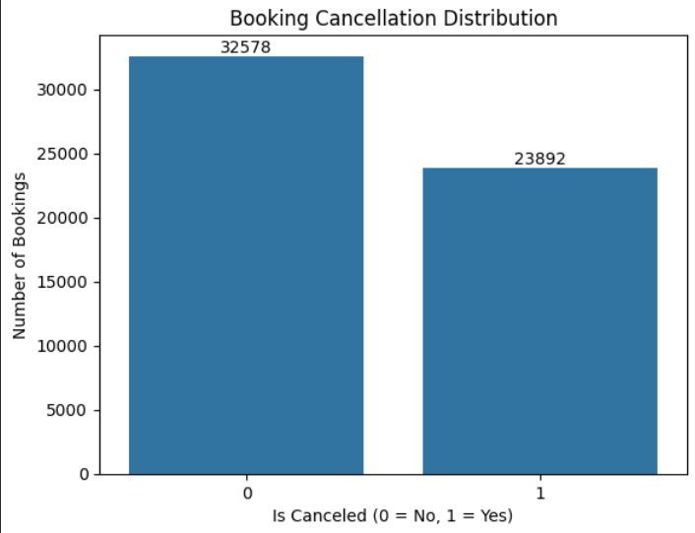
Approach:- 3.2 :- Booking per Hotel Type :-
This chart shows the number of bookings made for each hotel type, such as City Hotel and Resort Hotel. It helps compare booking volume across hotel categories and understand which hotel type receives more reservations.
ax = sns.countplot(data=df, x='hotel')
plt.title('Booking per Hotel Type')
plt.xlabel('Hotel Type')
plt.ylabel('Number of Bookings')
for i in ax.containers:
plt.bar_label(i)
plt.show()
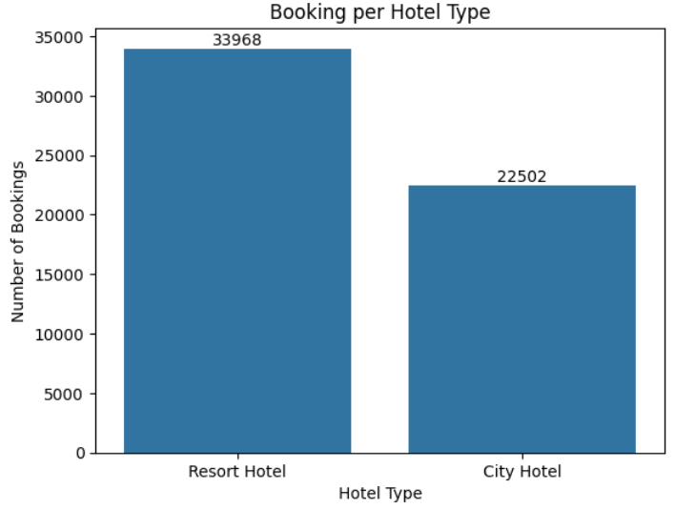
Approach:- 3.3 :- Distribution of Average Daily Rate (ADR) :-
A histogram was created using sns.histplot() to analyze the distribution of the Average Daily Rate (ADR) in the dataset. The adr column was plotted with 50 bins to observe how booking prices are spread across different ranges, and kde=True was used to add a smooth density curve for better understanding of the distribution pattern. The figure size was adjusted using plt.figure(figsize=(10, 6)), and the chart was labeled with an appropriate title and x-axis label for clarity.
plt.figure(figsize=(10, 6))
sns.histplot(data=df, x='adr', bins=50, kde=True)
plt.title('Distribution of Average Daily Rate (ADR)')
plt.xlabel('ADR')
plt.show()

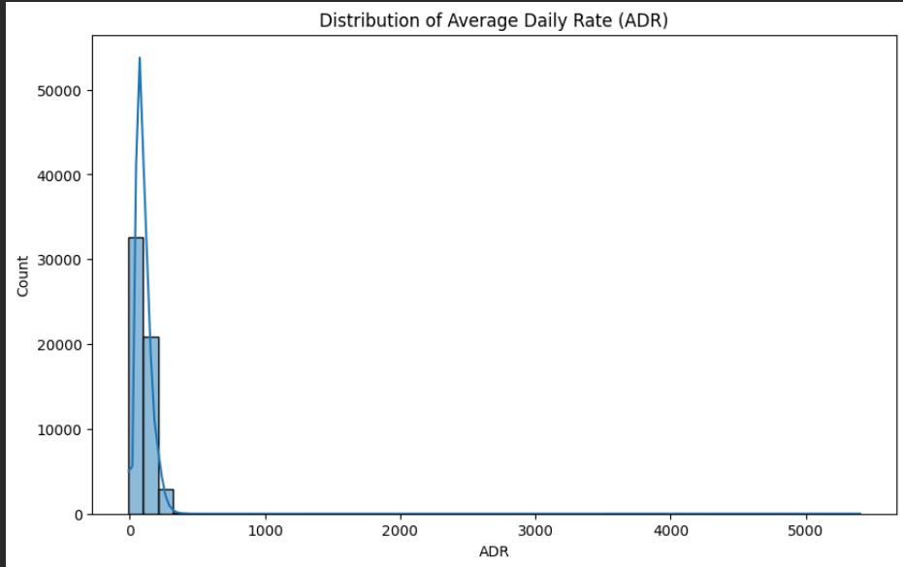
Approach:- 3.4 :- Booking Trends Over Time :-
To analyze how bookings changed over time, the reservation_status_date column was first converted into datetime format using pd.to_datetime(). Then, monthly booking counts were calculated by grouping the data month-wise with df['reservation_status_date'].dt.to_period('M'). A line plot was created to visualize the booking trend over time, where markers were added for each month to make the pattern easier to observe. The chart was further customized with title, axis labels, grid, and layout adjustments for better readability.
# Ensure the date column is in datetime format
df['reservation_status_date'] = pd.to_datetime(df['reservation_status_date'])
# Now extract the month and count bookings
monthly_bookings = df.groupby(df['reservation_status_date'].dt.to_period('M')).size()
# Plot the monthly bookings
monthly_bookings.plot(kind='line', figsize=(12, 6), marker='o', color='Teal')
plt.title('Monthly Booking Trends')
plt.xlabel('Month')
plt.ylabel('Number of Bookings')
plt.grid(True)
plt.tight_layout()
plt.show()

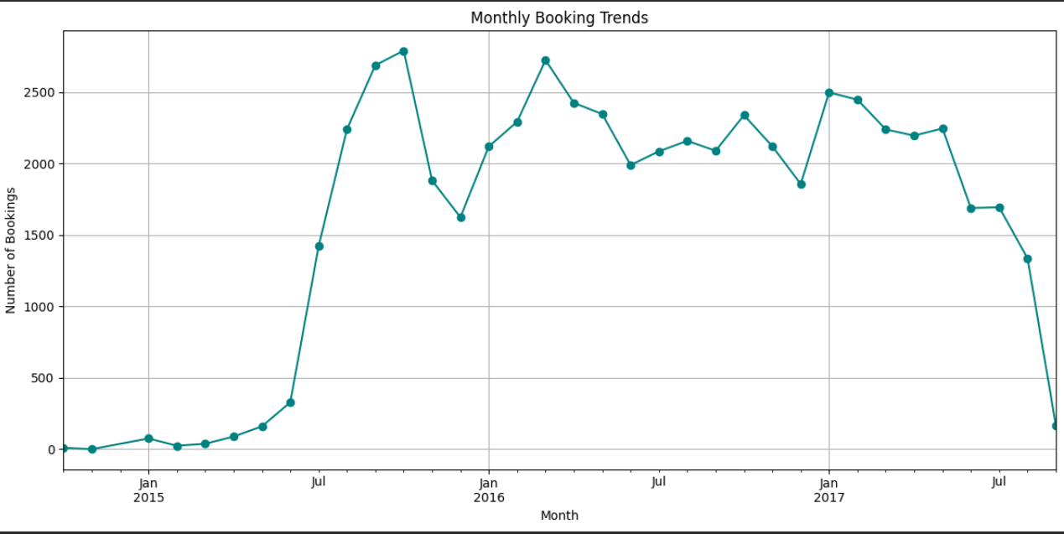
Approach:- 3.5 :- Lead Time vs. Booking Cancellation :-
A scatter plot was created using sns.scatterplot() to examine the relationship between lead time and booking cancellation. The is_canceled column was placed on the x-axis and lead_time on the y-axis to observe how lead time varies between canceled and non-canceled bookings. The alpha=0.5 parameter was used to make overlapping points more visible by adding transparency, and the figure size was adjusted for better readability. This visualization helps in identifying whether bookings made further in advance are more likely to be canceled.
plt.figure(figsize=(10, 6))
sns.scatterplot(data=df, x='is_canceled', y='lead_time', alpha=0.5)
plt.title('Lead Time vs. Booking Cancellation')
plt.xlabel('Lead Time')
plt.ylabel('Booking Cancellation')
plt.show()

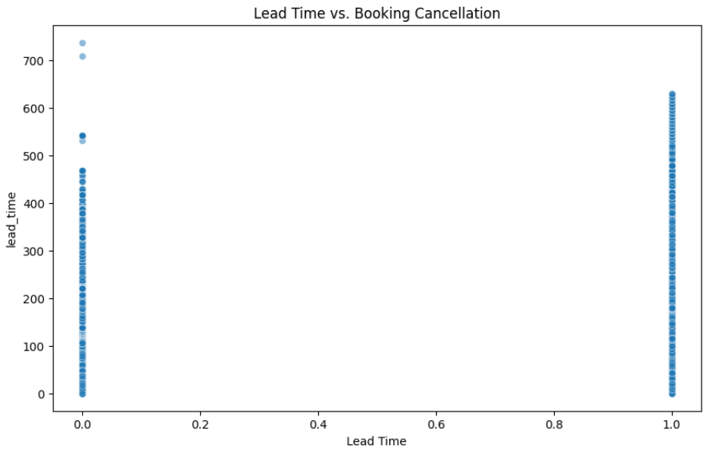
Approach:- 3.6 :- Correlation Heatmap :-
A correlation heatmap was created to examine the relationship between numerical variables in the dataset. The correlation matrix was first generated using df.corr(numeric_only=True), and then visualized with sns.heatmap(). The annot=True parameter was used to display the correlation values inside each cell, cmap='coolwarm' was applied to represent positive and negative correlations through color intensity, and fmt=".2f" was used to show correlation values up to two decimal places. This visualization helps in identifying how strongly different numerical features are related to each other.
plt.figure(figsize=(12,8))
sns.heatmap(df.corr(numeric_only=True), annot=True, cmap='coolwarm', fmt=".2f")
plt.title("Correlation Heatmap")
plt.show()
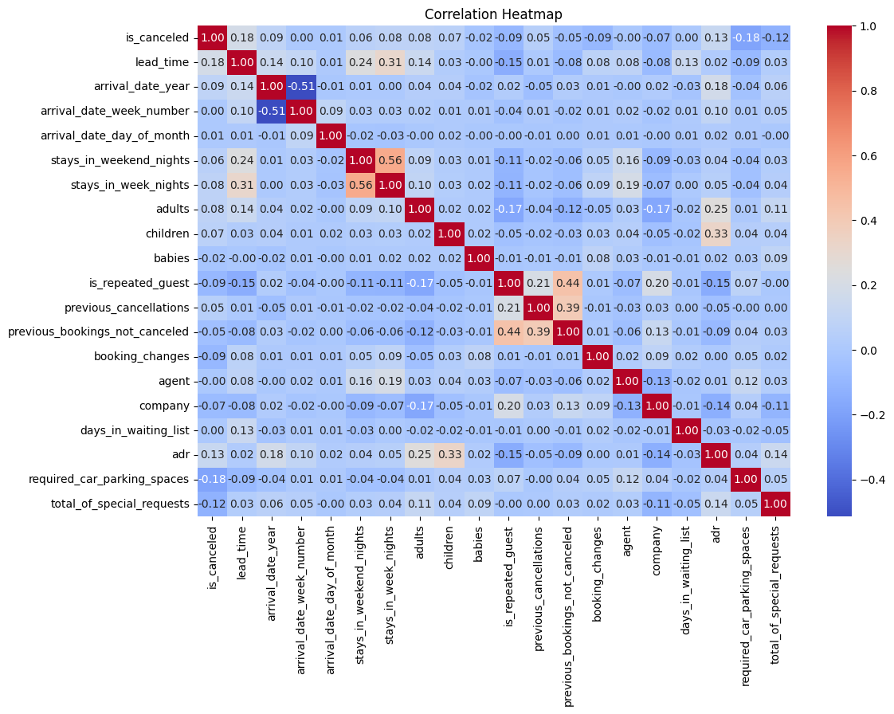
Task 4 Time Series Analysis: Analyzing trends and patterns over time.
Ans Approach:Time Series Analysis :-
In this step, time series analysis was performed to study booking and cancellation patterns over time. First, the arrival_date_year and arrival_date_month columns were combined to create a new year_month column in datetime format, which provided a proper timeline for analysis. Monthly booking counts were then calculated using groupby('year_month').size().sort_index() to observe how the number of bookings changed over time.
To further analyze cancellation trends, the dataset was filtered for canceled bookings using df[df['is_canceled'] == 1], and monthly cancellation counts were calculated in a similar way. Finally, line plots were created for both monthly bookings and monthly cancellations to visualize trends, fluctuations, and seasonality over time.
# Combine year and month into datetime format (first of each month)
df['year_month'] = pd.to_datetime(df['arrival_date_year'].astype(str) + '-' + df['arrival_date_month'] + '-01')

# Count monthly bookings
df.groupby('year_month').size().sort_index()

# Filter canceled bookings and count per month
df[df['is_canceled']== 1].groupby('year_month').size().sort_index()

# Monthly bookings
monthly_bookings = df.groupby('year_month').size()
monthly_bookings.plot(figsize=(12,5), title="Monthly Bookings Over Time")
plt.ylabel("Number of Bookings")
plt.show()

# Monthly cancellations
df[df['is_canceled'] == 1].groupby('year_month').size().plot(figsize=(12,5), title="Monthly Cancellations Over Time", color='red')
plt.ylabel("Cancellations")
plt.show()
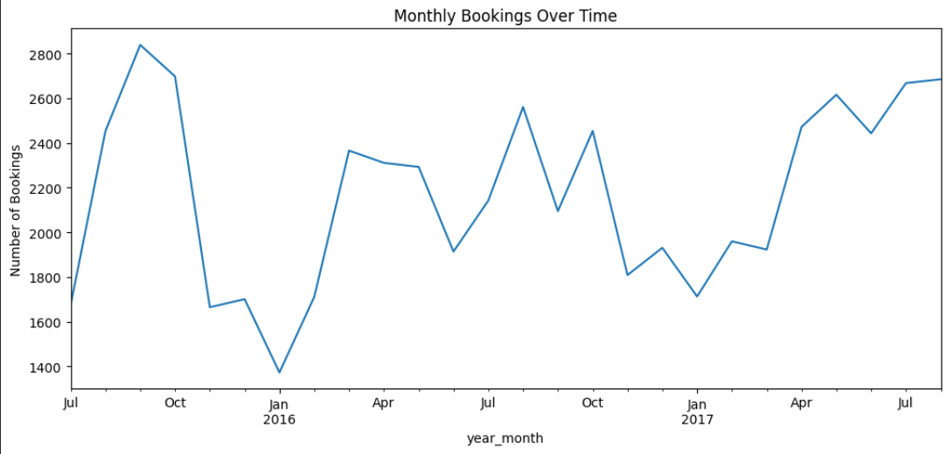

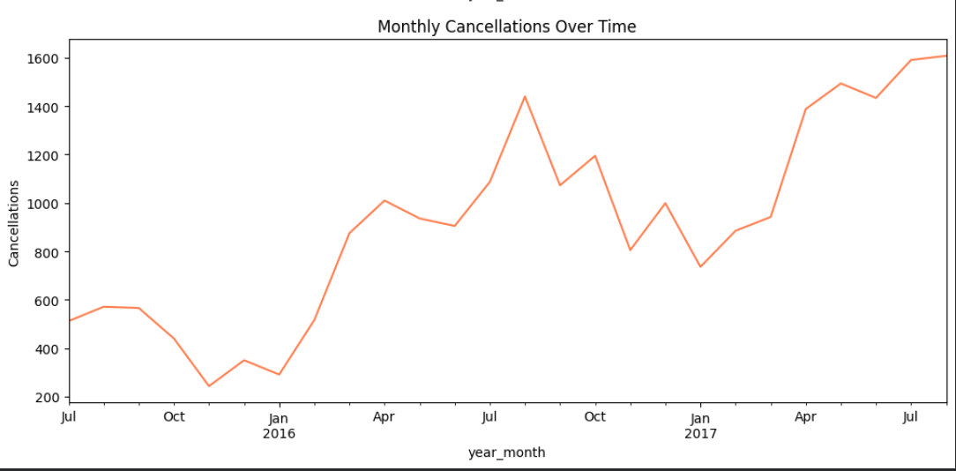

Task 5 Segmentation Analysis: Identifying and analyzing different customer segments.
Ans Approach: Customer Type Segmentation :-
Segmentation analysis was performed using the customer_type column to understand cancellation behavior across different customer groups. A count plot was created with customer_type on the x-axis and is_canceled as the hue to compare canceled and non-canceled bookings for each segment. In addition, df.groupby('customer_type')['is_canceled'].mean() was used to calculate the average cancellation rate for each customer type, helping to identify which segment had a higher tendency to cancel bookings.
ax = sns.countplot(data=df, x='customer_type', hue='is_canceled')
plt.title("Cancellations by Customer Type")
for i in ax.containers:
plt.bar_label(i)
plt.show()
# Get counts of each combination of customer_type and is_canceled
df.groupby('customer_type')['is_canceled'].mean()
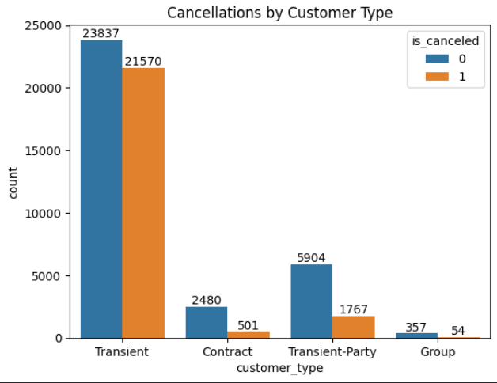

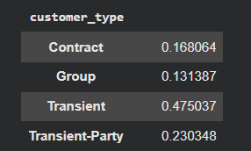
repeated = df[df['is_repeated_guest'] == 1]
non_repeated = df[df['is_repeated_guest'] == 0]

print("Repeated Guest Cancellation Rate:", repeated['is_canceled'].mean())
print("Non-Repeated Guest Cancellation Rate:", non_repeated['is_canceled'].mean())

sns.countplot(data=df, x='is_repeated_guest', hue='is_canceled')
plt.title('Cancellation by Repeated Guests')
plt.show()

df.groupby('is_repeated_guest')['is_canceled'].mean()

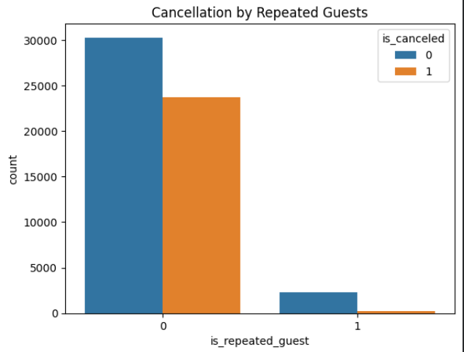

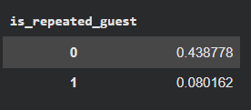
Task 6 Booking and Cancellation Analysis: Examining booking attributes and their impact on cancellations and ADR.
Ans Approach:
Cancellation by Hotel Type :-
To analyze how hotel type affects booking cancellations, the average cancellation rate was calculated using df.groupby('hotel')['is_canceled'].mean(). This grouped the data by hotel category and measured the proportion of canceled bookings for each type. The result was then visualized using a bar chart to compare cancellation rates between different hotel types.
df.groupby('hotel')['is_canceled'].mean().plot(kind='bar')
plt.title("cancellation rate by hotel")
plt.ylabel("cancellation rate")
plt.show()
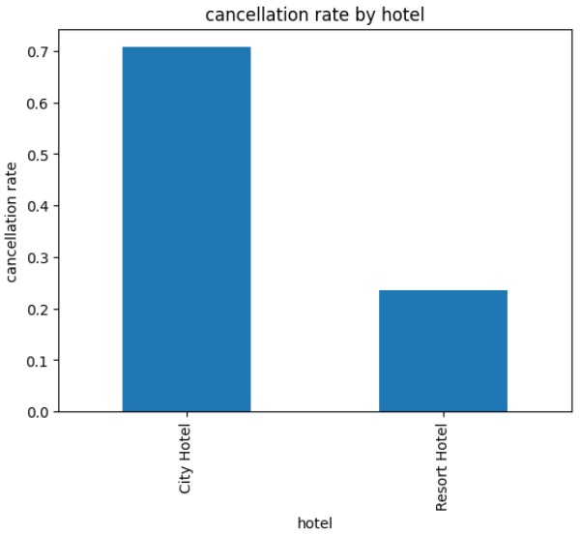
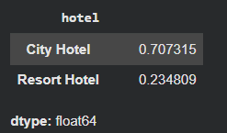
df.groupby('hotel')['is_canceled'].mean()
Approach:- Lead Time Impact :-
To examine the impact of lead time on booking cancellations, a box plot was created using sns.boxplot() with is_canceled on the x-axis and lead_time on the y-axis. This helped compare the distribution of lead time for canceled and non-canceled bookings. In addition, df.groupby('is_canceled')['lead_time'].describe() was used to generate summary statistics for lead time across both booking statuses.
sns.boxplot(data=df, x='is_canceled', y='lead_time')
plt.title("Lead Time vs Cancellation")
plt.show()
df.groupby('is_canceled')['lead_time'].describe()
# df.groupby('is_canceled')['lead_time'].mean()
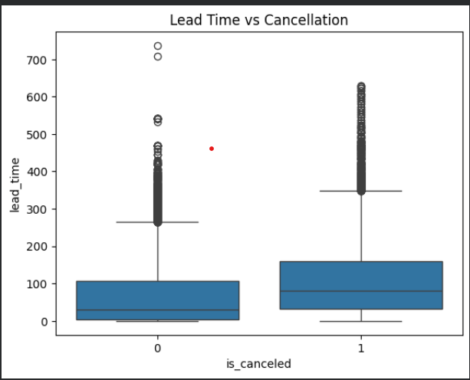
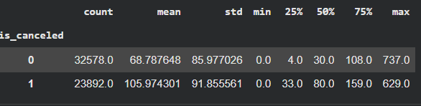
Approach:- ADR vs Cancellations :-
To analyze the relationship between Average Daily Rate (ADR) and booking cancellations, a box plot was created using sns.boxplot() with is_canceled on the x-axis and adr on the y-axis. This helped compare the distribution of ADR values for canceled and non-canceled bookings. Additionally, df.groupby('is_canceled')['adr'].describe() was used to generate summary statistics of ADR based on cancellation status.
sns.boxplot(data=df, x='is_canceled', y='adr')
plt.title("ADR vs Cancellations")
plt.show()
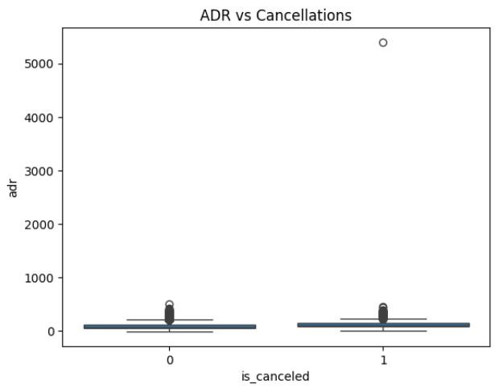
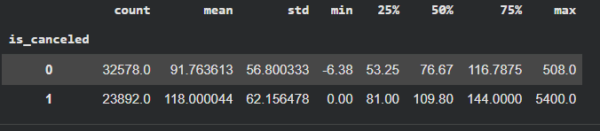
# Summary statistics of ADR grouped by cancellation status
df.groupby('is_canceled')['adr'].describe()
Approach:- Deposit Type Impact :-
To examine how deposit type influences booking cancellations, the average cancellation rate was calculated for each deposit category using df.groupby('deposit_type')['is_canceled'].mean(). The result was then visualized with a bar chart to compare cancellation rates across different deposit types.
df.groupby('deposit_type')['is_canceled'].mean().plot(kind='bar')
plt.title("Cancellation Rate by Deposit Type")
plt.ylabel("Cancellation Rate")
plt.show()
df.groupby('deposit_type')['is_canceled'].mean()
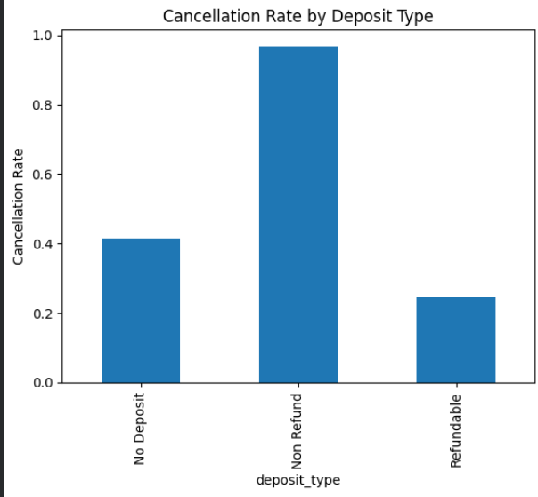
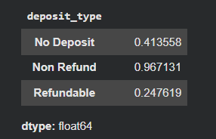
Task 7 Actionable Insights: Providing recommendations based on the analysis to improve hotel operations and customer satisfaction.
Ans Approach:
Key Insights:
Higher cancellations in City Hotels:
The analysis shows that City Hotels experience a higher cancellation rate than Resort Hotels. Since City Hotels also receive a larger share of total bookings, this makes cancellations a more significant issue for this hotel type.
Unusually high cancellations in Non-Refund bookings:
Bookings under the Non-Refund deposit type show an exceptionally high cancellation rate. Since non-refundable bookings are generally expected to have lower cancellations, this pattern may indicate a booking policy issue, operational gap, or possible inconsistency in the data.
Transient customers are more cancellation-prone:
Among customer segments, Transient customers contribute the most to booking cancellations, while Contract and Group customers appear comparatively more stable and reliable.
Repeat guests are more dependable:
Guests who have booked before are much less likely to cancel compared to first-time or non-repeated guests. This highlights the importance of customer loyalty in maintaining stable bookings.
Special requests vary across customer types:
Certain customer groups, especially Transient and Contract guests, tend to make more special requests. This suggests that service expectations differ across segments and operational planning should account for that.
City Hotels generate higher ADR:
The Average Daily Rate (ADR) is higher for City Hotels than Resort Hotels, indicating stronger revenue potential per booking and possibly reflecting differences in customer profile, location, or service positioning.

Recommendations:
Reduce cancellation risk in City Hotels:
Since City Hotels face a greater cancellation burden, hotel management should review cancellation policies, booking flexibility, and guest communication strategies to reduce last-minute cancellations.
Investigate Non-Refund booking behavior:
The unusually high cancellation rate in Non-Refund bookings should be examined carefully to identify whether it is caused by data issues, booking system loopholes, or operational policy problems.
Target transient guests with retention strategies:
As transient customers show a higher tendency to cancel, hotels can introduce incentives such as discounts on prepaid bookings, limited-time offers, or added-value benefits to encourage commitment.
Strengthen loyalty programs:
Since repeat guests are more reliable, hotels should focus on improving loyalty programs through reward points, personalized offers, upgrades, or smoother rebooking experiences.
Prioritize reliable customer segments:
Contract and group customers appear more stable, so hotels can benefit from strengthening relationships with these segments through corporate tie-ups, group packages, and long-term booking offers.
Prepare staff for segment-specific service needs:
Because some customer types place more special requests, hotel teams should be trained to respond efficiently to these needs. Better handling of such requests can improve guest satisfaction and overall service quality.
Use pricing strategically:
Since City Hotels already command a higher ADR, pricing strategies can be aligned with value-added services such as loyalty perks, early-booking offers, or cancellation protection to improve both revenue and customer retention.
Objective questions
TASK 1 .What is the average lead time for bookings that are cancelled versus those that are not cancelled?
Ans Approach:
df.groupby('is_canceled')['lead_time'].mean()
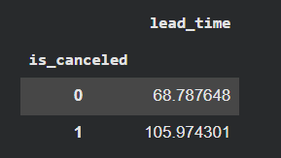
TASK 2 .Which month has the highest number of bookings?
Ans Approach:
df['arrival_date_month'].value_counts().idxmax()
Output:- `August`
TASK 3 .What is the distribution of ADR (Average Daily Rate) across different customer types?
Ans Approach:
sns.boxplot(data=df, x='customer_type', y='adr')
plt.title("ADR Distribution by Customer Type")
plt.show()
df.groupby('customer_type')['adr'].describe()
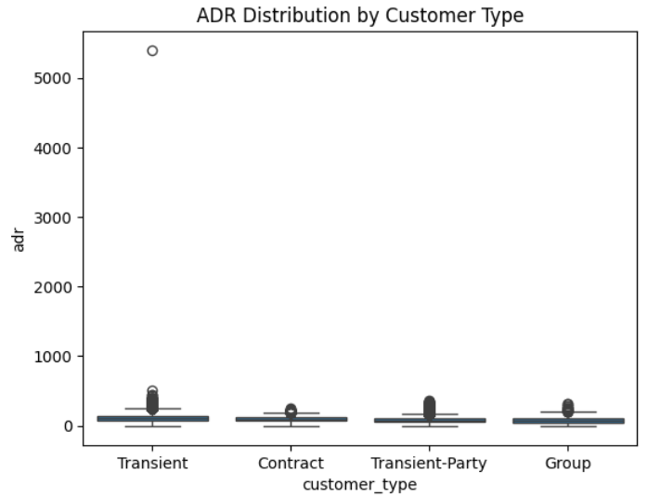
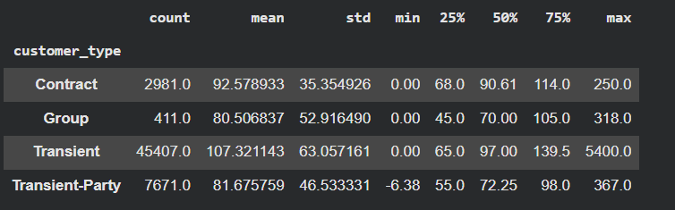

TASK 4 .How many bookings had special requests, and what is the average number of special requests per booking?
Ans Approach:
# Count of bookings with any special request
(df['total_of_special_requests'] > 0).sum()

# Average number of special requests per booking
df['total_of_special_requests'].mean()
output - np.float64(0.6206658402691695)
TASK 5 .What is the cancellation rate for each market segment?
Ans Approach:
# Cancellation rate for each market segment
df.groupby('market_segment')['is_canceled'].mean()
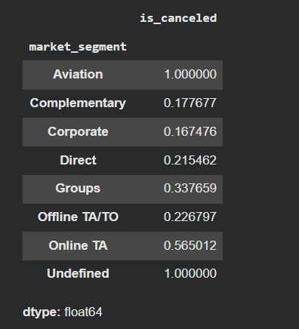
TASK 6. Which distribution channel has the highest average ADR?
Ans Approach:
df.groupby('distribution_channel')['adr'].mean().idxmax()
Output :- `GDS`

TASK 7 .What is the correlation between lead time and the length of stay?
Ans Approach:
df['length_of_stay'] = df['stays_in_week_nights'] + df['stays_in_weekend_nights']
df['lead_time'].corr(df['length_of_stay'])
Output :- `np.float64(0.31827157953643465)`

TASK 8 .How many bookings include children and/or babies?
Ans Approach:
int(((df['children'] > 0) | (df['babies'] > 0)).sum())
Output :- `9103`

TASK 9 What is the average lead time for repeated guests compared to new guests?
Ans Approach:
df.groupby('is_repeated_guest')['lead_time'].mean()
Output :-
is_repeated_guest | lead_time
0 | 82.442255
1 | 17.160469

TASK 10 What is the most common combination of reserved room type and assigned room type?
Ans Approach:
df.groupby(['reserved_room_type', 'assigned_room_type']).size().idxmax()
Output :- ('A', 'A')
Subjective questions
- How does the lead time affect the likelihood of booking cancellations?
Ans Approach:
Lead time has a significant impact on booking cancellations. The analysis shows that canceled bookings have a higher average lead time than non-canceled bookings, which means bookings made far in advance are more likely to be canceled. In contrast, bookings made closer to the check-in date are relatively less likely to be canceled.
lead_time_by_cancellation = df.groupby('is_canceled')['lead_time'].mean()
print("Average Lead Time:\n", lead_time_by_cancellation)

plt.figure(figsize=(6, 5))
lead_time_by_cancellation.plot(kind='bar', color=['blue', 'coral'], edgecolor='black')
plt.title('Average Lead Time by Cancellation Status')
plt.xlabel('Cancellation Status (0 = Not Canceled, 1 = Canceled)')
plt.ylabel('Average Lead Time (days)')
plt.xticks([0, 1], ['Not Canceled', 'Canceled'], rotation=0)
plt.grid(axis='y', linestyle='--', alpha=0.7)
plt.tight_layout()
plt.show()

df.groupby('is_canceled')['lead_time'].mean()
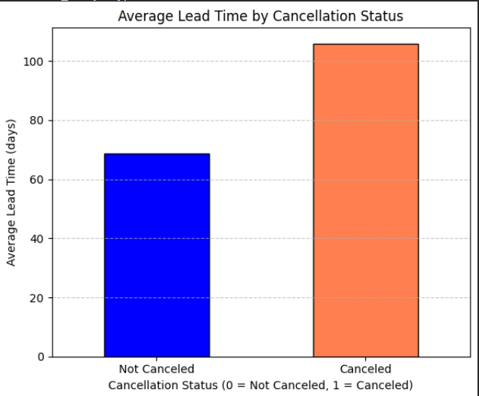

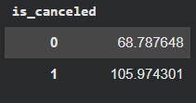
Insights:
- Guests who book well in advance have more time to change or cancel their travel plans.
- Higher lead time is associated with a greater chance of cancellation.
- Shorter lead time bookings appear to be more stable and reliable.
Recommendations:
- Hotels can closely monitor bookings with high lead time, as they carry a greater cancellation risk.
- Special confirmation emails, reminders, or flexible retention offers can be used for such bookings to reduce cancellations.
- Hotels may also consider reviewing cancellation policies for long lead-time bookings to improve booking security and forecasting accuracy.
Q2 What impact do special requests have on booking cancellations?
Ans Approach:
# Group by number of special requests and calculate cancellation rate
cancellation_by_requests = df.groupby('total_of_special_requests')['is_canceled'].mean()
cancellation_by_requests

# Plot the result
plt.figure(figsize=(10, 5))
cancellation_by_requests.plot(kind='bar', color='blue', edgecolor='black')
plt.title('Cancellation Rate by Number of Special Requests')
plt.xlabel('Number of Special Requests')
plt.ylabel('Cancellation Rate')
plt.xticks(rotation=0)
plt.tight_layout()
plt.show()

# Group by number of special requests and calculate cancellation rate
df.groupby('total_of_special_requests')['is_canceled'].mean()
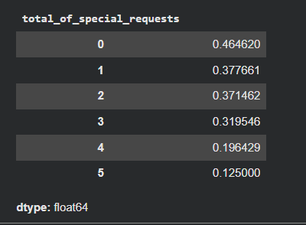
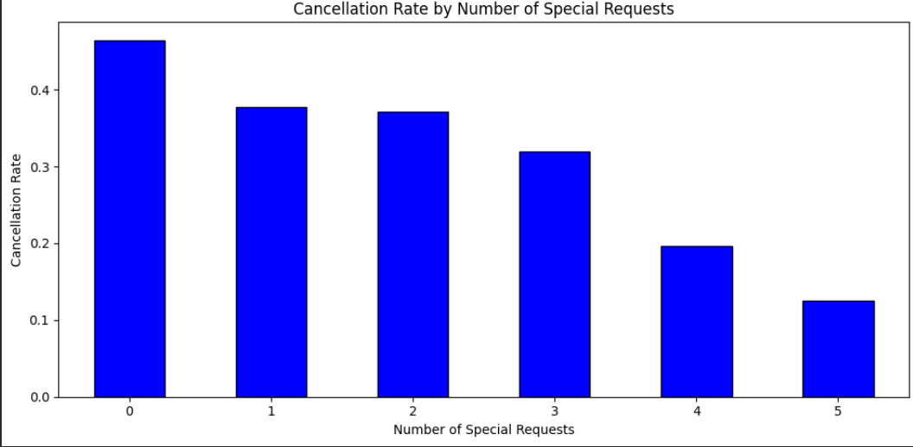
Insights:
- The chart shows a clear inverse relationship between the number of special requests and cancellation rate.
- Guests with 0 special requests have the highest cancellation rate, while guests with 4–5 special requests show a much lower cancellation rate.
- This suggests that customers who make more special requests are generally more serious about their stay and therefore less likely to cancel.
- On the other hand, bookings with no special requests may represent less committed customers, making them more prone to cancellation.
Recommendations:
- Hotels can treat bookings with no special requests as relatively higher-risk and monitor them more closely for possible cancellations.
- For guests who make multiple special requests, hotels should ensure these requests are fulfilled efficiently, as these customers appear more committed and valuable.
- Special request information can be used as a behavioral indicator in cancellation-risk analysis, helping hotels improve forecasting and overbooking decisions.
- Hotels may also encourage guests to share preferences or special requirements during booking, as this can improve engagement and strengthen booking commitment.
Q3 What trends can be observed in the booking behaviour of international guests compared to domestic guests?
Ans Approach:
df['guest_origin'] = df['country'].apply(lambda x: 'Domestic' if x == 'PRT' else 'International')

# Group by guest origin and calculate key statistics
guest_comparison = df.groupby('guest_origin').agg({
'is_canceled': 'mean',
'lead_time': 'mean',
'adr': 'mean',
'stays_in_week_nights': 'mean',
'stays_in_weekend_nights': 'mean',
'total_of_special_requests': 'mean'
})

# Calculate total stay duration
guest_comparison['avg_total_stay'] = guest_comparison['stays_in_week_nights'] + guest_comparison['stays_in_weekend_nights']

# Display DataFrame (no print)
guest_comparison
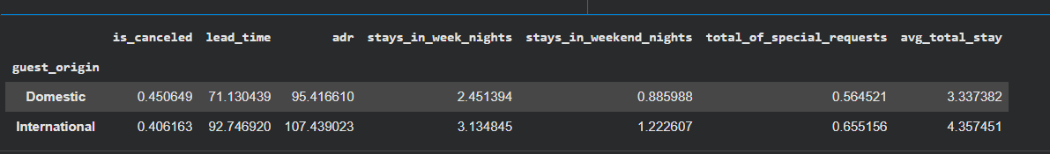
Insights:
- Cancellation behaviour may differ between domestic and international guests, showing which segment is more likely to cancel bookings.
- Lead time helps identify whether international guests tend to book further in advance compared to domestic guests.
- ADR comparison shows whether one group spends more per booking than the other.
- By combining stays_in_week_nights and stays_in_weekend_nights, the average total stay duration can be compared to see which guest segment stays longer.
- The average number of special requests also gives an idea of service expectations across guest origins.
Recommendations:
- Hotels can create different booking and marketing strategies for domestic and international guests based on their cancellation behaviour and booking lead time.
- If international guests show longer stays or higher ADR, hotels can design premium packages or targeted offers for them.
- If one segment places more special requests, hotel staff can be trained accordingly to improve guest satisfaction.
- Guest origin can also be used as an important factor in customer segmentation and personalization strategies to improve both operations and service quality.

Q4 What is the impact of the day of the week on booking cancellations?
Ans Approach:
To analyze whether cancellations vary by arrival day, a proper arrival_date column was first created by combining arrival year, month, and day using pd.to_datetime(). From this date, the day name was extracted into a new column called arrival_day_of_week. The average cancellation rate for each day was then calculated using groupby('arrival_day_of_week')['is_canceled'].mean() and arranged in weekday order from Monday to Sunday. Finally, a bar chart was plotted to compare cancellation rates across different arrival days.
# Create a datetime column if not already present
df['arrival_date'] = pd.to_datetime(df['arrival_date_year'].astype(str) + '-' +
df['arrival_date_month'] + '-' +
df['arrival_date_day_of_month'].astype(str))

# Extract day of the week (Monday=0, Sunday=6)
df['arrival_day_of_week'] = df['arrival_date'].dt.day_name()

# Calculate cancellation rate by day of the week
cancellation_by_day = df.groupby('arrival_day_of_week')['is_canceled'].mean().reindex([
'Monday', 'Tuesday', 'Wednesday', 'Thursday', 'Friday', 'Saturday', 'Sunday'
])

# Display cancellation rates
cancellation_by_day

#plot

cancellation_by_day.plot(kind='bar', figsize=(8,5), color='Blue', title='Cancellation Rate by Arrival Day of Week')
plt.ylabel('Cancellation Rate')
plt.xlabel('Day of Week')
plt.xticks(rotation=45)
plt.show()
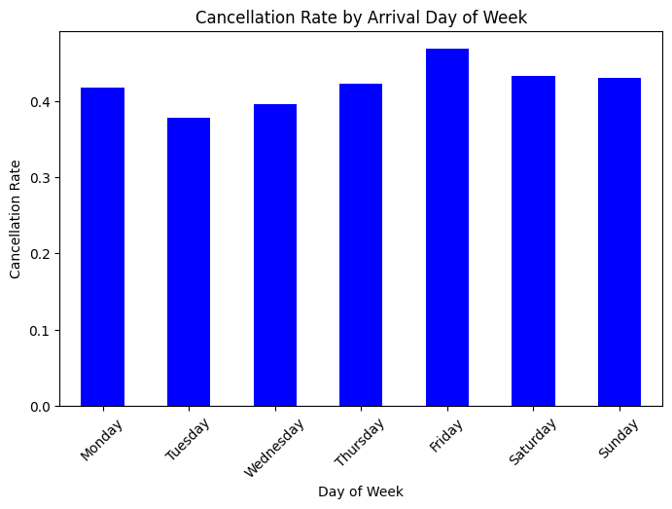
Insights :-
• Friday and Saturday show the highest cancellation rates (~30.5% and ~30.1%), suggesting weekend bookings are more prone to be canceled.
• Thursday also has a relatively high cancellation rate (~27.7%).
• Tuesday has the lowest cancellation rate (~24.3%), implying more stable mid-week bookings.
• Monday, Wednesday, and Sunday fall in the middle, ranging from ~25.5% to ~26.8%.

Recommendations :-
Reduce Weekend Cancellations (Friday & Saturday):
- Use non-refundable pricing or stricter cancellation windows.
- Offer advance booking discounts to lock in guests earlier.
- Send reminders or personalised confirmations a few days before check-in.
Leverage Mid-Week Stability (Tuesday):
- Maintain flexible policies to drive bookings for low-risk days.
- Introduce mid-week stay promotions or business travel bundles.
Watch Thursday Trends:
- Target Thursday guests with custom offers or reassurance messaging to reduce dropouts.
Segment Analysis:
- Cross-reference day-of-week cancellations with market segment or guest type.
- Apply targeted strategies based on who cancels more often on specific days.
Q5
Approach:
To answer this, guests were first classified into Domestic and International categories by creating a guest_origin column, where Portugal (PRT) was treated as domestic and all other countries were treated as international. After that, international bookings were filtered separately and the top 10 countries were identified using value_counts() on the country column.
For behavioural comparison, booking patterns of domestic and international guests were analyzed using grouped metrics such as cancellation rate, average lead time, ADR, average length of stay, and total special requests. Finally, a bar chart was created to visualize the top international guest source countries.
# Create guest_origin column if not present
df['guest_origin'] = df['country'].apply(lambda x: 'Domestic' if x == 'PRT' else 'International')

# Filter international guests
international_guests = df[df['guest_origin'] == 'International']

# Count bookings by country and get top 10
top_countries = international_guests['country'].value_counts().head(10)
top_countries

# Plot
top_countries.plot(kind='bar', figsize=(10,5), color='blue', title='Top 10 Countries of International Guests')
plt.ylabel('Number of Bookings')
plt.xlabel('Country')
plt.xticks(rotation=45)
plt.show()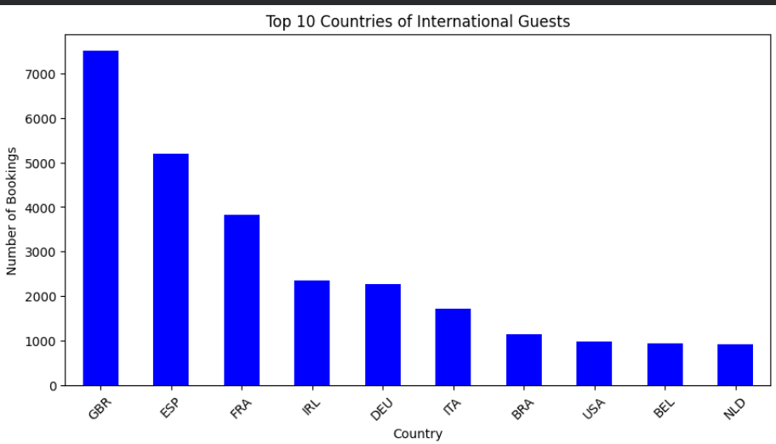
Insights:
- The largest share of international bookings comes from European countries, especially the United Kingdom, France, Spain, Germany, and Italy. Countries like Ireland, Belgium, Brazil, the Netherlands, and the USA also appear among the top international sources.
- International guests cancel less frequently than domestic guests, indicating comparatively more stable booking behaviour.
- They also tend to book earlier, as reflected by their higher average lead time.
- International guests show a higher ADR, meaning they contribute more revenue per night on average.
- Their average stay duration is longer, and they also make more special requests, suggesting higher engagement and possibly greater service expectations compared to domestic guests.

Recommendations:
- Hotels should focus more on high-performing international markets such as the UK, France, Spain, and Germany through targeted promotions and region-specific marketing campaigns.
- Since international guests tend to book earlier and stay longer, hotels can design early-booking offers, bundled stay packages, or premium service packages for these customers.
- Because international guests also make more special requests, hotels should strengthen guest support services, such as multilingual communication, travel assistance, and personalized amenities.
- For domestic guests, where cancellations are relatively higher, the hotel can work on retention strategies like weekend deals, loyalty benefits, or better cancellation/booking flexibility to improve booking stability.
- As international guests generate a higher ADR, hotels can use dynamic pricing and value-added services during peak travel periods to maximize revenue from this segment.

